**Vector:** A vector is a object that represents both magnitude and direction. It's often represented as an array of numbers or coordinates.

e.g.

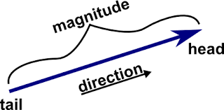

**Scalar:** A scalar refers to a single numerical value, in contrast to a vector which is an array of values. Scalars are used to scale vectors.

Examples of scalars are individual real numbers, such as 5, -2.3 etc.

**Scaling:** Scaling, in the context of vectors, involves the multiplication of a vector by a scalar. This process involves multiplying each component of the vector by the scalar value.

**Linear Combination:**

A linear combination is a fundamental concept in linear algebra that involves creating a new vector by scaling and summing other vectors.

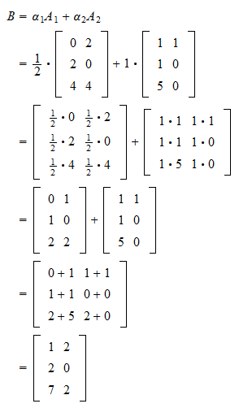

The term "linear" in "linear combination" refers to a property that when you alter only one scalar while keeping the others constant in the combination, the resulting vector still lies on the line formed by the original vectors in the space.

**Span:** The span of a set of vectors refers to the collection of all their possible linear combinations.

**Independent Vectors:**

* If each new vector adds a new dimension to the span, then these vectors are independent.
* Each new vector contributes to a different direction or dimension in the space, expanding the span to include new areas.

**Dependent Vectors:**

* If the new vector doesn't introduce a new dimension but rather lies within the span formed by the existing vectors, it indicates dependency.

**Basis Vectors:**

The basis of a vector space is a set of linearly independent vectors that span the full space.